We, then, create a handful of filters. Some low-level filters are shown in Fig. <$n:figure:lowLevelFilters>

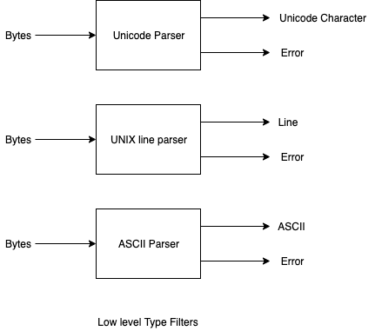
Fig. <$n:figure:lowLevelFilters> Low Level Filters

(Filters can further be chained together to recognize more interesting, more complicated, types).

